Year 9 Hard materials Technology

Design Booklet

Skills:
The Design Process
Tools and equipment
Construction methods
Evaluation and Analysis

Name

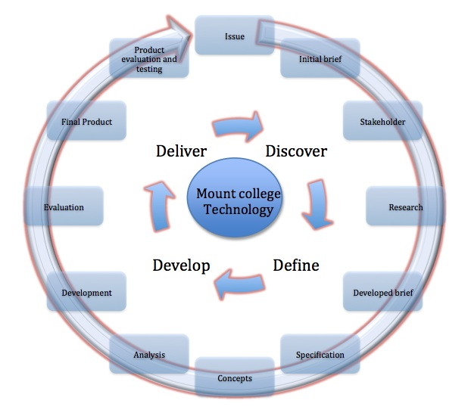

Lev-el | Technical Practice |  |  |  | Technological Knowledge |  |  |  | Nature of technology
 | Brief development |  |  |  | Technological modelling |  |  |  | Characteristics of technology
2 | +Produce a simple need for a product and why it should be designed.  +Create a simple design brief.  +Produce a simple specification. |  | P | T | +Able to explain why modelling is undertaken.  +Able to explain what a prototype is. |  | P | T | +Able to explain how technology is influenced by society and environment.  +Able to explain how technology has influenced society. |  | P |  | T
3 | +Produce a detailed range of needs to design a product  +Select a chosen need and use this to develop a design brief  +Create a specification |  | P | T | +Able to explain how modelling different aspects of your design it can help you with decision making  +Able to explain why a prototype is used to help develop a final product  +Able to tell what the difference between a prototype and a model is |  | P | T | +Able to explain how technology has helped develop human possibilities  +Show how inspiration for ideas was found from different forms |  | P |  | T
4 | +Produce a detailed range of needs to be able to design a product giving a possible outcome  +Use the chosen need to produce a detailed design brief  +Create detailed specification explaining each point so that a outcome matching that of the design brief is made |  | P | T | +Use modelling to help you evaluate and develop different concepts  +Able to explain why a prototype is used to help continued development of a final product |  | P | T | +Able to explain how public opinion has an impact on technological developments  +Able to explain why it is important that technical knowledge is written down |  | P |  | T
5 | All of above plus;-  + Justify all points on design brief and specification in terms of the client and the community |  | P | T | All of above plus;-  + why the modelling first will help provide evidence for choices made and prevention of risk |  | P | T | + Able to explain how technology works with other learning areas to maximise potential solutions for problems. |  | P |  | T
 | Planning for practice |  |  |  | Technical Products |  |  |  | Characteristics of technological outcomes
2 | + Produce simple plan of how are you going to make your product  + Complete logbook, explaining what you are doing each week and why |  | P | T | +Have a basic understanding of materials and know how there properties effect how you work with them. |  | P | T | +Able to explain how products must physically and functionally work together to achieve maximum performance | P |  | T
3 | +Produce a plan of construction using knowledge of tools and equipment explaining why you have selected them  +Identify the materials that you plan to use, analysing why you are using them above other |  | P | T | +Have a complex knowledge of material and there properties.  + Able to explain how different materials function and how to work with them. |  | P | T | +Able to explain how final products are used and functions they could perform. | P |  | T
4 | All of above;-  +Analyse planning schedules, developing them as you go, justifying decisions made. |  | P | T | All of above;-  +Able to select materials based on there properties and how they will perform for a specific job |  | P | T | +Able to explain how products can be defined in terms of time and date they were made.  +Able to explain how problems can often influence future designs. | P |  | T
5 | All of above;-  +Critically analyse planning, to create more a more effective planning schedule |  | P | T | All of above;-  +Critically evaluate material properties to select the best possible for a specific design |  | P | T | All of above;-  +Able to explain how and why designs can be seen as an outcome and a system | P |  | T
 | Outcome development & evaluation |  |  |  | Technical systems |  |  |  | Project Assessment,  Overall Feedback  Final Project level=  Final feedback=
2 | +Produce a basic product that meets the brief.  +Produce a basic evaluation against the need, brief and specification |  | P | T | +Able to explain what specific technical language is when related to the work being developed. |  | P | T
3 | +Evaluate the need to develop design ideas.  +Evaluate ideas against the specification to develop an idea that best suits the need.  +Evaluate the product for how well it suits the need, brief and specification |  | P | T | +Able to explain how technological systems have an input, process and output. |  | P | T
4 | All of above;-  +Undertake ongoing evaluations throughout design process, with use of testing, modelling and critical analysis. |  | P | T | +Able to explain what a sub-system is and how they work within a system. |  | P | T
5 | All of above;-  +Critically analyse all aspects of the design process, justify why decisions were made throughout.  +Justify all decisions, modelling, product and final evaluation using feedback from the clients |  | p | T | +Able to explain the implication of sub-systems within the design |  | P | T
Key |  | P= Self-assessment |  |  |  | T= Teacher assessment

Glossary;
As you work through the course write the meanings of key words.

1.

2.

3.

4.

5.

6.

7.

8.

9.

10.

11.

12.

Drawing Techniques

Oblique

Isometric

Puzzle pieces

Tools;
As you use each tool listed below explain what it is used for and the most effective way of using it.

Metal ruler

Square

Marking guage

Craft knife

Bench hook

Vice

Tennon saw

Coping saw

Scroll saw

Plane

Hand drill

Palm sander

Belt sander

Construction techniques;
Using the knowledge you have of the different tools you are going to create the simple wooden puzzle that you draw as part of your drawing practice;

As you progress with the project you are to complete the construction log below, stating what each task you undertook, why and the tools you used. You should also state any problems that you occurred when using each tool and how you managed this.

Job undertaken | Tools used | Explanation of task, problems that occurred, fixes
Once you have completed your explain, what you could have done better and how your puzzle could be improved, you can use diagrams and annotation to helpo you;-

Types of finishes

Explain why finishes need to be applied to a product?

Give an explanation of each of the below finishes and how it is applied ?

1. Paint

2. Varnish

3. Oil

4. Wax

5. Stain

Before any finish can be applied you must prepare the surface explain below how to apply a finish of paint and varnish to wood.

Varnish Paint

Design Brief

You have been asked to design and construct a stool that will reflect a kiwiana theme.

Product Analysis
Look at these related items and briefly state, how they could be used in the design of your stool.

Product Analysis
Using star profiles critically analyse each of these existing products

1

2

3

What has your product analysis shown you?
……………………………………………………………………………………………………………………………………………………………………………………………………………………………………
……………………………………………………………………………………………………………………………………………………………………………………………………………………………………
……………………………………………………………………………………………………………………………………………………………………………………………………………………………………
………………………………………………………………………………………………………………………………………………………………………………………………………………………………………………………………………………………………………………………………………………………
……………………………………………………………………………………………………………………………………………………………………………………………………………………………………
……………………………………………………………………………………………………………………………………………………………………………………………………………………………………
……………………………………………………………………………………………………………………………………………………………………………………………………………………………………
……………………………………………………………………………………………………………………………………………………………………………………………………………………………………
…………………………………………………………………………………………………………………

Refined Brief
Using your research refine your design brief to enable you to create a product that is fully meets your initial brief. It should include who your possible clients could be, age range and why they may need them.
……………………………………………………………………………………………………………………………………………………………………………………………………………………………………
……………………………………………………………………………………………………………………………………………………………………………………………………………………………………
……………………………………………………………………………………………………………………………………………………………………………………………………………………………………
………………………………………………………………………………………………………………………………………………………………………………………………………………………………………………………………………………………………………………………………………………………
……………………………………………………………………………………………………………………………………………………………………………………………………………………………………
Specification

1; The stool should be the between and high, with the seat between and .

2; It should be for the age range of and , because

3; The materials should be strong and durable as

4; The construction should be sturdy and robust because

5; The design should

6;

7;

8;

Initial thoughts

Initial ideas
1;

2,

3,

Analysis of Ideas
Below explain what has been successful and unsuccessful for each of the 3 ideas. Make sure you refer back to the specifications when writing the notes below.

Idea 1
……………………………………………………………………………………………………………………………………………………………………………………………………………………………………
………………………………………………………………………………………………………………………………………………………………………………………………………………………………………………………………………………………………………………………………………………………
……………………………………………………………………………………………………………………………………………………………………………………………………………………………………

Idea 2
……………………………………………………………………………………………………………………………………………………………………………………………………………………………………
………………………………………………………………………………………………………………………………………………………………………………………………………………………………………………………………………………………………………………………………………………………
……………………………………………………………………………………………………………………………………………………………………………………………………………………………………

Idea 3
……………………………………………………………………………………………………………………………………………………………………………………………………………………………………
………………………………………………………………………………………………………………………………………………………………………………………………………………………………………………………………………………………………………………………………………………………
……………………………………………………………………………………………………………………………………………………………………………………………………………………………………

Development of Idea
Using your initial ideas develop a final solution to fulfil your design brief. Use sketches and models which explain the following.
∗ How the design works.
∗ Exploded views of different parts
* Development changes that have be made and why from your initial ideas

Construction Plan
Flowchart of construction
Produce a flowchart showing how you plan to construct your stool, (continue to the following page if not enough room)

Evaluation
Reflect how successful has your design been; How well does your product fulfil your design brief and specification? What could you have improved or developed further to better your product? What do perspective users think about it?
……………………………………………………………………………………………………………………………………………………………………………………………………………………………………
………………………………………………………………………………………………………………………………………………………………………………………………………………………………………………………………………………………………………………………………………………………
……………………………………………………………………………………………………………………………………………………………………………………………………………………………………
……………………………………………………………………………………………………………………………………………………………………………………………………………………………………
………………………………………………………………………………………………………………………………………………………………………………………………………………………………………………………………………………………………………………………………………………………
……………………………………………………………………………………………………………………………………………………………………………………………………………………………………
……………………………………………………………………………………………………………………………………………………………………………………………………………………………………
………………………………………………………………………………………………………………………………………………………………………………………………………………………………………………………………………………………………………………………………………………………
……………………………………………………………………………………………………………………………………………………………………………………………………………………………………
……………………………………………………………………………………………………………………………………………………………………………………………………………………………………
………………………………………………………………………………………………………………………………………………………………………………………………………………………………………………………………………………………………………………………………………………………
……………………………………………………………………………………………………………………………………………………………………………………………………………………………………
……………………………………………………………………………………………………………………………………………………………………………………………………………………………………

Construction Log
Record any problems/ successes you had during the construction, stating jobs done, tools and techniques used
Week | Construction process

